**PHYSICAL EDUCATION LESSON-BUILD YOUR OWN OBSTACLE COURSE!**

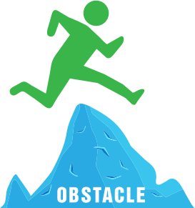

**Hello Kids and Families,**

**Today’s lesson is going to allow you to be creative! You are going to construct your own obstacle course! It can be inside or outside. You need to have an adult help you with the construction and be with you as you go through it! I am going to give you some suggestions but be creative!**

**Rules:**

* **Have an adult with you to help organize your obstacle course**
* **Ask which items you can use and where you can build it**
* **Please make your obstacle course on the ground. No obstacles of height!**
* **Try to use a variety of movements in your obstacle course such as jog, skip, going under, going over, hopping, weaving, balancing etc.**
* **Always have fun and please remember safety!!**
* **If an adult has a stopwatch on their phone or a watch, please have them time you. See if you can do it a few times and see if your time changes!**

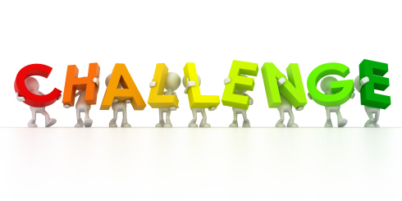

**I HAVE INCLUDED A FEW EXAMPLES THAT YOU CAN WATCH TO GET SOME IDEAS! PLEASE CLICK ON THE LINK BELOW!**

<https://youtu.be/9ciHBE5J2Vc>

**THIS VIDEO IS FROM ONE OF OUR VERY OWN 2ND GRADERAT DDPS! Great job**, **Evie! It is titled, “Evie Aiello obstacle course fun”**

<https://youtu.be/Ya-LLW_YXnM>

***Have fun everyone! Please send an email or a message on Dojo when you have completed the lesson! If you would like to send us a picture or list of some of the things you created in your obstacle course that would be awesome! Be safe and be creative!

[MillerA@dvsd.org](mailto:MillerA@dvsd.org) or [FeissJ@dvsd.org](mailto:FeissJ@dvsd.org)

**KEEP MOVING,**

**MRS. MILLER & MR. FEISS 😊**